**Conduct Pearson’s regression to determine the agreement between all parameters with the outputs (Cu and Cc) and present basic linear fittings.**

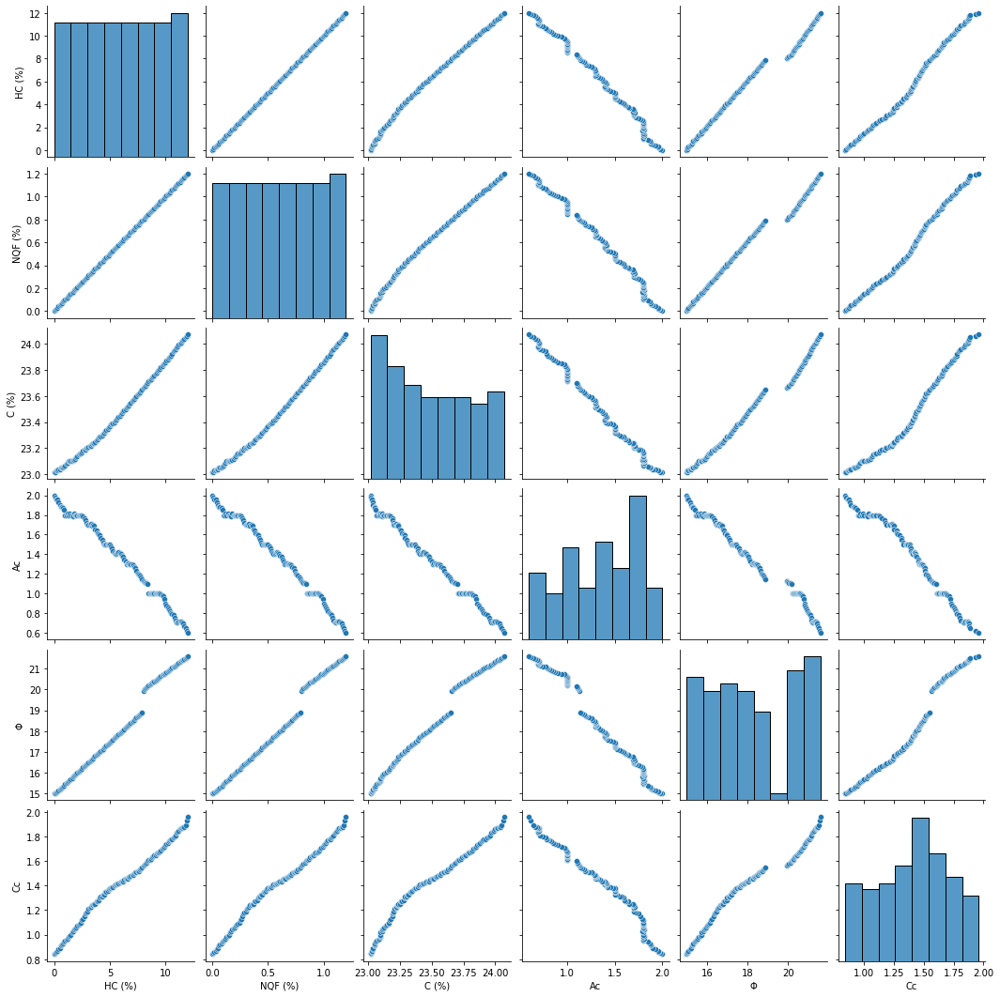

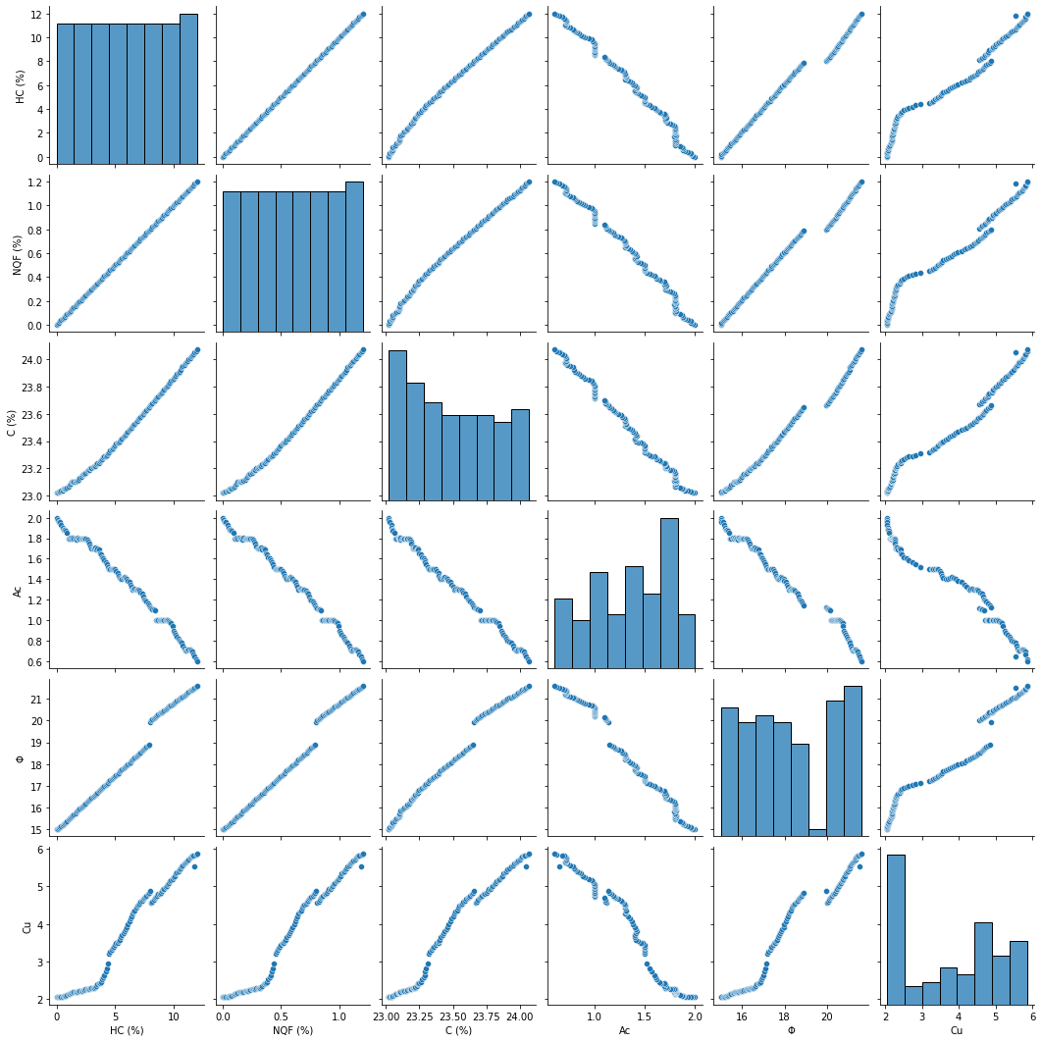

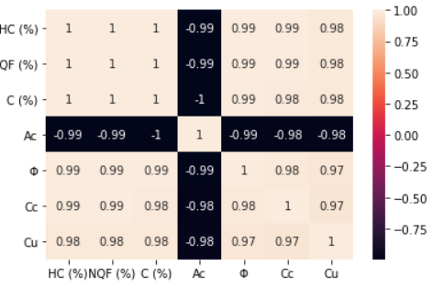

**Present frequency histograms of the variables.**

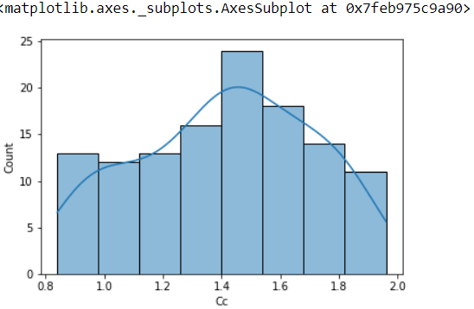

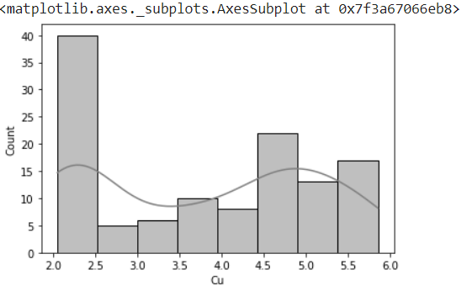

**Train, Validate and Test. Present the architecture of the program.**

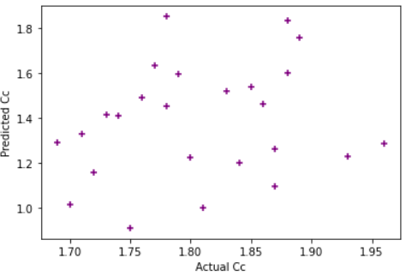

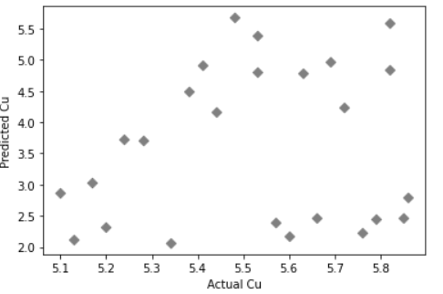

**Conduct performance evaluation in comparison between measured and predicted values using MLR, R^2, RMSE, MAE, MSE, and any other evaluation parameter.**

|  |  |  |
| --- | --- | --- |
|  | **Cc** | **Cu** |
| Mean absolute error | 0.01606553594871081 | 0.19669182684062414 |
| Mean squared error | 0.0003900187262419388 | 0.05865062449095186 |
| Root mean squared error | 0.019748891772500523 | 0.24217891008705086 |
| R2 score | 0.9954294909043978 | 0.9579525098471435 |

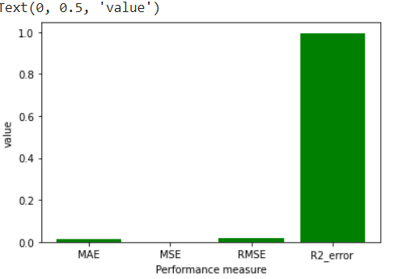

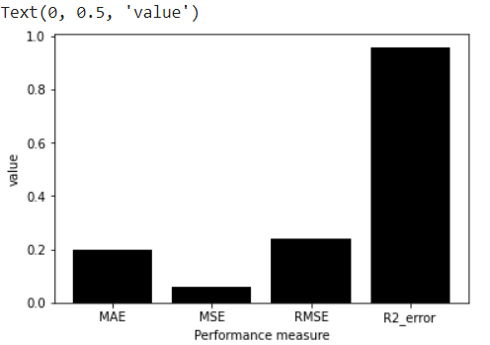



**Present the parametric study graph.**

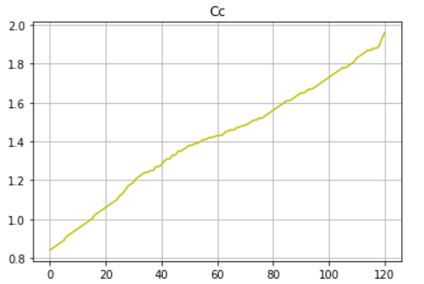

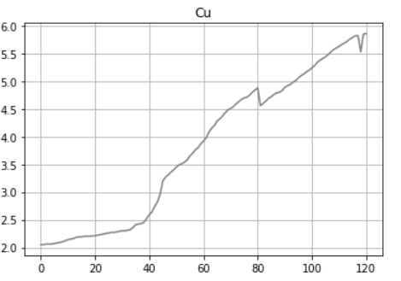

**Conduct sensitivity analysis to determine the influence of each parameter on the predicted parameters.**

